HOMEWORK 2 - Exercises in Faraway Introduction

$\text{STOR 590, FALL 2020}$

Rui Li

8/27/2020

**Instructions**

Question 1: Faraway, page 24, exercise 2 (“rock” dataset)

Question 2: Faraway, page 24, exercise 5 (“prostate” dataset)

In each case, I’d like you to conduct an analysis, following the six bullet points listed in the question. Lengthy answers are not required, but you should be sure to address each of these bullet points in your answer.

Due time and date: 1:00 pm Friday, August 28

**Exercises**

Since this is a review chapter, it is best to consult the recommended background texts for specific questions on linear models. However, it is worthwhile gaining some practice using R on some real data. Your data analysis should consist of:

*1. An initial data analysis that explores the numerical and graphical characteristics of the data.*

*2. Variable selection to choose the best model.*

*3. An exploration of transformations to improve the fit of the model.*

*4. Diagnostics to check the assumptions of your model.*

*5. Some predictions of future observations for interesting values of the predictors.*

*6. An interpretation of the meaning of the model with respect to the particular area of application.*

There is always some freedom in deciding which methods to use, in what order to apply them, and how to interpret the results. So there may not be one clear right answer and good analysts may come up with different models.

**Exercise 2** The *rock* data - use *perm* as the response.

# Load *rock* data

library(faraway)

## Warning: package 'faraway' was built under R version 3.6.3

head(rock)

## area peri shape perm  
## 1 4990 2791.90 0.0903296 6.3  
## 2 7002 3892.60 0.1486220 6.3  
## 3 7558 3930.66 0.1833120 6.3  
## 4 7352 3869.32 0.1170630 6.3  
## 5 7943 3948.54 0.1224170 17.1  
## 6 7979 4010.15 0.1670450 17.1

str(rock)

## 'data.frame': 48 obs. of 4 variables:  
## $ area : int 4990 7002 7558 7352 7943 7979 9333 8209 8393 6425 ...  
## $ peri : num 2792 3893 3931 3869 3949 ...  
## $ shape: num 0.0903 0.1486 0.1833 0.1171 0.1224 ...  
## $ perm : num 6.3 6.3 6.3 6.3 17.1 17.1 17.1 17.1 119 119 ...

According to the information above, we know that *rock* is a data frame with 48 observations and 4 numeric columns.

**area:** Area of pores space, in pixels out of 256 by 256.

**peri:** Perimeter in pixels.

**shape:** Perimeter/sqrt(area).

**perm:** Permeability in milli-Darcies.

# Initial Data Analysis

#Summarize the dataset  
summary(rock)

## area peri shape perm   
## Min. : 1016 Min. : 308.6 Min. :0.09033 Min. : 6.30   
## 1st Qu.: 5305 1st Qu.:1414.9 1st Qu.:0.16226 1st Qu.: 76.45   
## Median : 7487 Median :2536.2 Median :0.19886 Median : 130.50   
## Mean : 7188 Mean :2682.2 Mean :0.21811 Mean : 415.45   
## 3rd Qu.: 8870 3rd Qu.:3989.5 3rd Qu.:0.26267 3rd Qu.: 777.50   
## Max. :12212 Max. :4864.2 Max. :0.46413 Max. :1300.00

We have four numerical variables, and the six summary statistics show us the general distribution of the variables. I am going to analyze in depth with each variable, and the *perm* response.

#Distribution of each variable  
#Perm  
library(ggplot2)

## Warning: package 'ggplot2' was built under R version 3.6.3

ggplot(rock, aes(x=perm)) +   
 geom_histogram(aes(y=..density..), bins = 20,fill = "white", col = "black") +   
 geom_density(alpha=.2, fill="#FF6666") +  
 geom_rug() +  
 labs(title = 'Distribution of Perm') +   
 theme(plot.title = element_text(hjust = 0.5, size=12, face="bold.italic"))

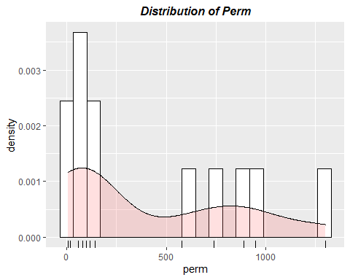

#Area  
ggplot(rock, aes(x=area)) +   
 geom_histogram(aes(y=..density..), bins = 20,fill = "white", col = "black") +   
 geom_density(alpha=.2, fill="#FF6666") +  
 geom_rug() +  
 labs(title = 'Distribution of Area') +   
 theme(plot.title = element_text(hjust = 0.5, size=12, face="bold.italic"))

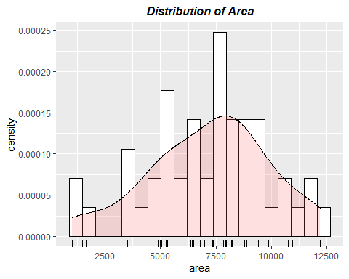

#Peri  
ggplot(rock, aes(x=peri)) +   
 geom_histogram(aes(y=..density..), bins = 20,fill = "white", col = "black") +   
 geom_density(alpha=.2, fill="#FF6666") +  
 geom_rug() +  
 labs(title = 'Distribution of Peri') +   
 theme(plot.title = element_text(hjust = 0.5, size=12, face="bold.italic"))

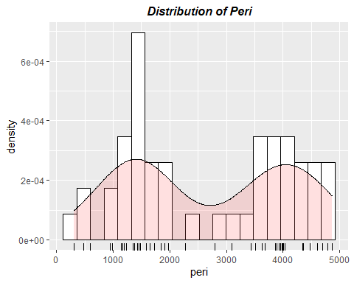

#Shape  
library(ggplot2)  
ggplot(rock, aes(x=shape)) +   
 geom_histogram(aes(y=..density..), bins = 20,fill = "white", col = "black") +   
 geom_density(alpha=.2, fill="#FF6666") +  
 geom_rug() +  
 labs(title = 'Distribution of Shape') +   
 theme(plot.title = element_text(hjust = 0.5, size=12, face="bold.italic"))

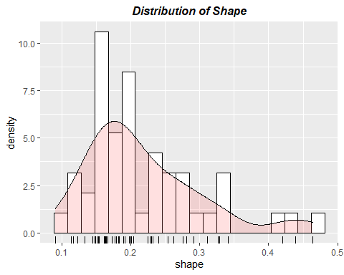

From the distribution plots above, we can see that there are some outliers in bothe *perm* response and *Shape* variable. We should be careful about them in the following analysis.

#Correlation between variables  
cor(rock)

## area peri shape perm  
## area 1.0000000 0.8225064 -0.1821611 -0.3966370  
## peri 0.8225064 1.0000000 -0.4331255 -0.7387158  
## shape -0.1821611 -0.4331255 1.0000000 0.5567208  
## perm -0.3966370 -0.7387158 0.5567208 1.0000000

#Pair Plots  
library(ggplot2)  
library(GGally)

## Warning: package 'GGally' was built under R version 3.6.3

## Registered S3 method overwritten by 'GGally':  
## method from   
## +.gg ggplot2

##   
## Attaching package: 'GGally'

## The following object is masked from 'package:faraway':  
##   
## happy

ggpairs(rock) +   
 ggtitle("Pair Plots of Rock") +   
 theme(plot.title = element_text(hjust = 0.5, size=12, face="bold.italic"))

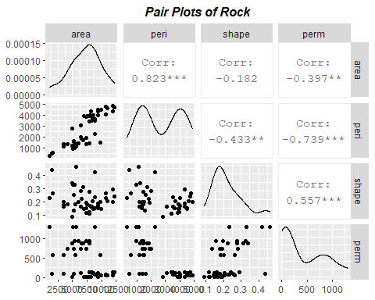

From the results above, we can see that *area*, *peri*, and *shape* has some correlations with *perm*. We can continue to define a linear model, and find deeper relationship.

# Variable Selection

#Build up full model  
full.lm = lm(formula = perm ~ ., data = rock)  
print(summary(full.lm))

##   
## Call:  
## lm(formula = perm ~ ., data = rock)  
##   
## Residuals:  
## Min 1Q Median 3Q Max   
## -750.26 -59.57 10.66 100.25 620.91   
##   
## Coefficients:  
## Estimate Std. Error t value Pr(>|t|)   
## (Intercept) 485.61797 158.40826 3.066 0.003705 **   
## area 0.09133 0.02499 3.654 0.000684 ***  
## peri -0.34402 0.05111 -6.731 2.84e-08 ***  
## shape 899.06926 506.95098 1.773 0.083070 .   
## ---  
## Signif. codes: 0 '***' 0.001 '**' 0.01 '*' 0.05 '.' 0.1 ' ' 1  
##   
## Residual standard error: 246 on 44 degrees of freedom  
## Multiple R-squared: 0.7044, Adjusted R-squared: 0.6843   
## F-statistic: 34.95 on 3 and 44 DF, p-value: 1.033e-11

#Apply backward selection model  
full.backward = step(full.lm, direction = "backward")

## Start: AIC=532.34  
## perm ~ area + peri + shape  
##   
## Df Sum of Sq RSS AIC  
## <none> 2663023 532.34  
## - shape 1 190360 2853383 533.66  
## - area 1 808191 3471213 543.06  
## - peri 1 2741707 5404730 564.32

print(summary(full.backward))

##   
## Call:  
## lm(formula = perm ~ area + peri + shape, data = rock)  
##   
## Residuals:  
## Min 1Q Median 3Q Max   
## -750.26 -59.57 10.66 100.25 620.91   
##   
## Coefficients:  
## Estimate Std. Error t value Pr(>|t|)   
## (Intercept) 485.61797 158.40826 3.066 0.003705 **   
## area 0.09133 0.02499 3.654 0.000684 ***  
## peri -0.34402 0.05111 -6.731 2.84e-08 ***  
## shape 899.06926 506.95098 1.773 0.083070 .   
## ---  
## Signif. codes: 0 '***' 0.001 '**' 0.01 '*' 0.05 '.' 0.1 ' ' 1  
##   
## Residual standard error: 246 on 44 degrees of freedom  
## Multiple R-squared: 0.7044, Adjusted R-squared: 0.6843   
## F-statistic: 34.95 on 3 and 44 DF, p-value: 1.033e-11

#Apply forward selection model  
full.forward <- step(lm(perm ~ 1, data=rock), list(upper=full.lm), direction='forward')

## Start: AIC=584.84  
## perm ~ 1  
##   
## Df Sum of Sq RSS AIC  
## + peri 1 4916322 4092864 548.97  
## + shape 1 2792290 6216896 569.04  
## + area 1 1417333 7591852 578.63  
## <none> 9009186 584.84  
##   
## Step: AIC=548.97  
## perm ~ peri  
##   
## Df Sum of Sq RSS AIC  
## + area 1 1239481 2853383 533.66  
## + shape 1 621651 3471213 543.06  
## <none> 4092864 548.97  
##   
## Step: AIC=533.66  
## perm ~ peri + area  
##   
## Df Sum of Sq RSS AIC  
## + shape 1 190360 2663023 532.34  
## <none> 2853383 533.66  
##   
## Step: AIC=532.34  
## perm ~ peri + area + shape

print(summary(full.forward))

##   
## Call:  
## lm(formula = perm ~ peri + area + shape, data = rock)  
##   
## Residuals:  
## Min 1Q Median 3Q Max   
## -750.26 -59.57 10.66 100.25 620.91   
##   
## Coefficients:  
## Estimate Std. Error t value Pr(>|t|)   
## (Intercept) 485.61797 158.40826 3.066 0.003705 **   
## peri -0.34402 0.05111 -6.731 2.84e-08 ***  
## area 0.09133 0.02499 3.654 0.000684 ***  
## shape 899.06926 506.95098 1.773 0.083070 .   
## ---  
## Signif. codes: 0 '***' 0.001 '**' 0.01 '*' 0.05 '.' 0.1 ' ' 1  
##   
## Residual standard error: 246 on 44 degrees of freedom  
## Multiple R-squared: 0.7044, Adjusted R-squared: 0.6843   
## F-statistic: 34.95 on 3 and 44 DF, p-value: 1.033e-11

I apply both backward and forward selection to the model, and have the same optimal model. According to the report, the optimal model is exactly the same as the full model, *perm ~ area + peri + shape*. However, the significant importance of variable *shape* is mild. We may think of improving the model by transforming some of the variables.

# Exploration of Transformations

*Transform the response perm*

#Box-Cox Transformation of the response  
library(MASS)  
full.bc = boxcox(perm ~ area + peri + shape, data=rock)

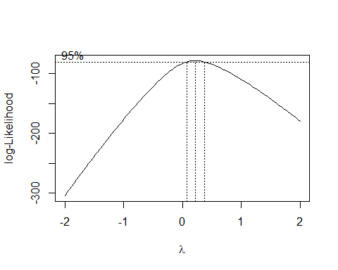

#Get the lamda of maximum log-Likelihood  
lamda.max = full.bc$x[full.bc$y==max(full.bc$y)]  
  
#Set up new Model  
bc.lm = lm(perm^lamda.max ~ area + peri + shape, data=rock)  
summary(bc.lm)

##   
## Call:  
## lm(formula = perm^lamda.max ~ area + peri + shape, data = rock)  
##   
## Residuals:  
## Min 1Q Median 3Q Max   
## -1.30235 -0.32020 0.09305 0.32367 1.06157   
##   
## Coefficients:  
## Estimate Std. Error t value Pr(>|t|)   
## (Intercept) 3.577e+00 3.451e-01 10.365 2.18e-13 ***  
## area 3.074e-04 5.445e-05 5.645 1.12e-06 ***  
## peri -1.025e-03 1.113e-04 -9.207 8.02e-12 ***  
## shape 1.242e+00 1.104e+00 1.125 0.267   
## ---  
## Signif. codes: 0 '***' 0.001 '**' 0.01 '*' 0.05 '.' 0.1 ' ' 1  
##   
## Residual standard error: 0.5359 on 44 degrees of freedom  
## Multiple R-squared: 0.7802, Adjusted R-squared: 0.7652   
## F-statistic: 52.06 on 3 and 44 DF, p-value: 1.601e-14

*Diagnostics of models before and after Box-Cox Transformation*

#Diagnostics befor transformation  
plot(full.lm)

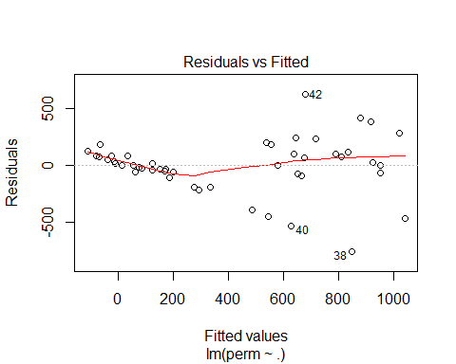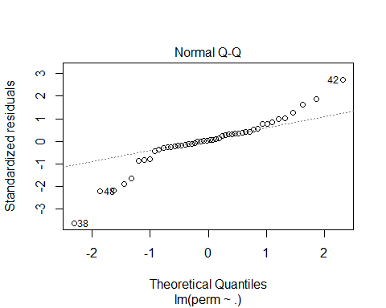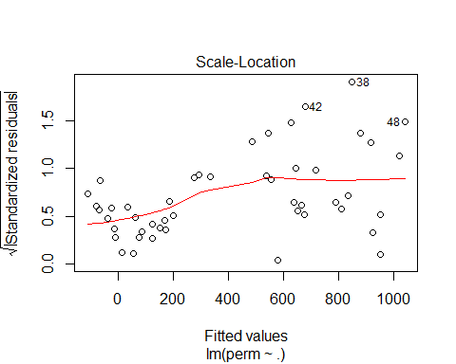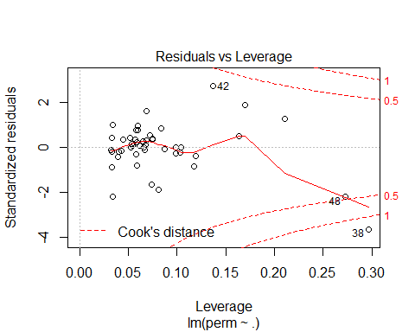

#Diagnostics after transformation  
plot(bc.lm)

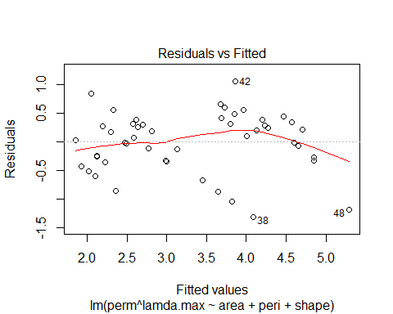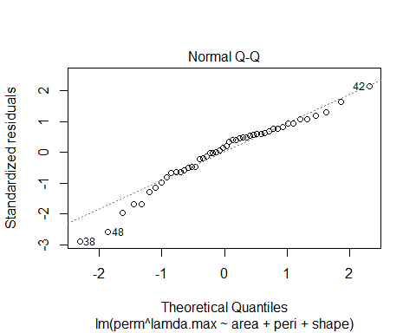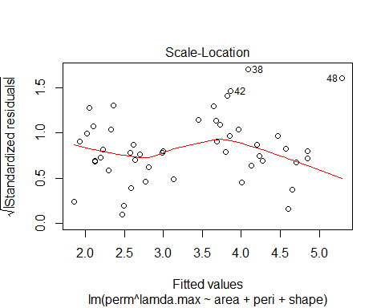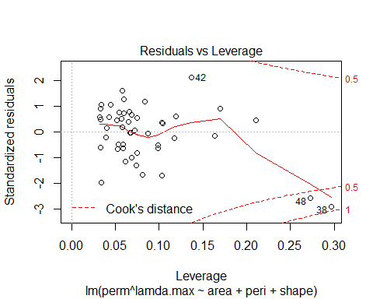

Compared to the old model, the new model does not perform better in the significat importance of *shape*. Also, the QQ-plot of the new model is less linear than the one of old model. Therefore, I will still keep the old model as the optimal one. I will continue to improve the model by transforming the predictions.

*Transform the predictors*

library(splines)  
#Spline Transformations on area  
spli.lm.area = lm(formula = perm ~ bs(area,4) + peri + shape, data = rock)  
summary(spli.lm.area)

##   
## Call:  
## lm(formula = perm ~ bs(area, 4) + peri + shape, data = rock)  
##   
## Residuals:  
## Min 1Q Median 3Q Max   
## -719.81 -97.11 -14.58 122.83 596.98   
##   
## Coefficients:  
## Estimate Std. Error t value Pr(>|t|)   
## (Intercept) 558.42225 239.10061 2.336 0.024489 *   
## bs(area, 4)1 -324.41847 355.51810 -0.913 0.366828   
## bs(area, 4)2 1140.63681 296.04926 3.853 0.000403 ***  
## bs(area, 4)3 455.24838 343.87564 1.324 0.192879   
## bs(area, 4)4 919.45714 304.15143 3.023 0.004302 **   
## peri -0.33123 0.05122 -6.466 9.4e-08 ***  
## shape 1072.78900 513.61243 2.089 0.042984 *   
## ---  
## Signif. codes: 0 '***' 0.001 '**' 0.01 '*' 0.05 '.' 0.1 ' ' 1  
##   
## Residual standard error: 236.8 on 41 degrees of freedom  
## Multiple R-squared: 0.7449, Adjusted R-squared: 0.7076   
## F-statistic: 19.95 on 6 and 41 DF, p-value: 9.523e-11

#Nature of the fit  
termplot(spli.lm.area, partial=TRUE,terms = 1)

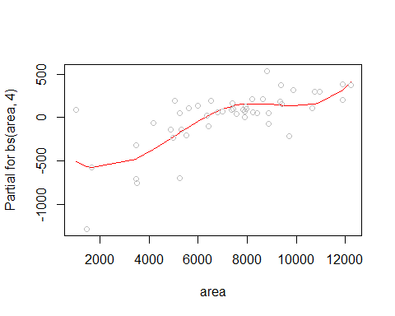

#Polynomial Transformations on peir  
spli.lm.peri = lm(formula = perm ~ area + bs(peri,4) + shape, data = rock)  
summary(spli.lm.peri)

##   
## Call:  
## lm(formula = perm ~ area + bs(peri, 4) + shape, data = rock)  
##   
## Residuals:  
## Min 1Q Median 3Q Max   
## -776.42 -82.72 26.21 112.62 521.38   
##   
## Coefficients:  
## Estimate Std. Error t value Pr(>|t|)   
## (Intercept) 4.913e+02 2.612e+02 1.881 0.067084 .   
## area 9.602e-02 3.228e-02 2.974 0.004903 **   
## bs(peri, 4)1 -5.614e+02 4.172e+02 -1.346 0.185758   
## bs(peri, 4)2 -5.681e+02 4.604e+02 -1.234 0.224297   
## bs(peri, 4)3 -1.595e+03 4.383e+02 -3.639 0.000758 ***  
## bs(peri, 4)4 -1.660e+03 4.586e+02 -3.619 0.000805 ***  
## shape 8.246e+02 5.687e+02 1.450 0.154686   
## ---  
## Signif. codes: 0 '***' 0.001 '**' 0.01 '*' 0.05 '.' 0.1 ' ' 1  
##   
## Residual standard error: 252.4 on 41 degrees of freedom  
## Multiple R-squared: 0.7101, Adjusted R-squared: 0.6677   
## F-statistic: 16.74 on 6 and 41 DF, p-value: 1.196e-09

#Nature of the fit  
termplot(spli.lm.peri, partial=TRUE,terms = 2)

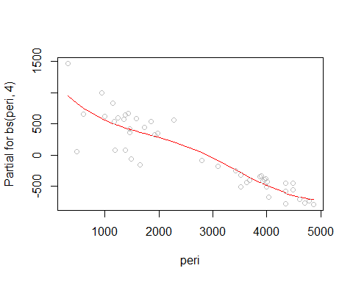

#Polynomial Transformations on shape  
spli.lm.shape = lm(formula = perm ~ area + peri + bs(shape,4), data = rock)  
summary(spli.lm.shape)

##   
## Call:  
## lm(formula = perm ~ area + peri + bs(shape, 4), data = rock)  
##   
## Residuals:  
## Min 1Q Median 3Q Max   
## -767.97 -47.91 14.56 82.50 678.38   
##   
## Coefficients:  
## Estimate Std. Error t value Pr(>|t|)   
## (Intercept) 555.01714 236.55311 2.346 0.02388 *   
## area 0.09499 0.02710 3.505 0.00112 **   
## peri -0.34963 0.05464 -6.399 1.17e-07 ***  
## bs(shape, 4)1 153.22661 320.04422 0.479 0.63465   
## bs(shape, 4)2 -159.56884 339.78225 -0.470 0.64111   
## bs(shape, 4)3 578.39233 473.13013 1.222 0.22851   
## bs(shape, 4)4 274.23832 299.20377 0.917 0.36473   
## ---  
## Signif. codes: 0 '***' 0.001 '**' 0.01 '*' 0.05 '.' 0.1 ' ' 1  
##   
## Residual standard error: 251.8 on 41 degrees of freedom  
## Multiple R-squared: 0.7115, Adjusted R-squared: 0.6693   
## F-statistic: 16.85 on 6 and 41 DF, p-value: 1.091e-09

#Nature of the fit  
termplot(spli.lm.shape, partial=TRUE,terms = 3)

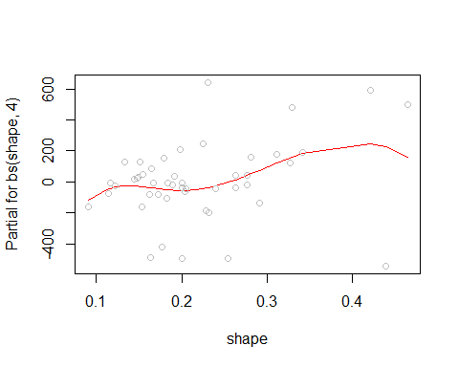

From the result, we can see that the partial for *peri* has negatively related to the constant fill, but do not add any significant, or improve the performance of the model. Thus, I will still choose my final model as *perm ~ area + peri + shape*.

# Diagnostics of the Choosing Model

plot(full.lm)



**Diagnosis Results:** From the *Residuals vs. fitted values*, we can see the scatterplot distributes randomly, with some exception outliers. From the *Normal Probability plot*, the points are generally follow the straight line. From the *Scale Lotion*, the plot shows radom pattern. From the *Cook’s distance*, we can see there are some outliers affecting the model. Thus, according to the results above, I will pick the full model,*perm ~ area + peri + shape*, as my optimal model for the future steps.

# Predictions of Future Observations

#New observations  
new.obs <- data.frame(  
 area = c(8, 800, 800, 800, 800, 8000),  
 peri = c(3, 3, 30, 300, 3000, 3000),  
 shape = c(5, 50, 5, 500, 0.05, 0.5)  
)  
  
#Predict based on 99% prediction interval  
full.pre = predict(full.lm, se.fit=T, newdata=new.obs, interval='prediction', level = .99)  
full.pre$fit

## fit lwr upr  
## 1 4980.6629 -1562.8912 11524.2169  
## 2 45511.1159 -22396.7351 113418.9670  
## 3 5043.7106 -1482.4446 11569.8657  
## 4 449990.1075 -232119.0217 1132099.2368  
## 5 -428.4353 -1229.4000 372.5293  
## 6 633.7491 -140.5311 1408.0293

From the results above, we can see that the shape has a great effect on the results.

# Interpretation of the Model

summary(full.lm)

##   
## Call:  
## lm(formula = perm ~ ., data = rock)  
##   
## Residuals:  
## Min 1Q Median 3Q Max   
## -750.26 -59.57 10.66 100.25 620.91   
##   
## Coefficients:  
## Estimate Std. Error t value Pr(>|t|)   
## (Intercept) 485.61797 158.40826 3.066 0.003705 **   
## area 0.09133 0.02499 3.654 0.000684 ***  
## peri -0.34402 0.05111 -6.731 2.84e-08 ***  
## shape 899.06926 506.95098 1.773 0.083070 .   
## ---  
## Signif. codes: 0 '***' 0.001 '**' 0.01 '*' 0.05 '.' 0.1 ' ' 1  
##   
## Residual standard error: 246 on 44 degrees of freedom  
## Multiple R-squared: 0.7044, Adjusted R-squared: 0.6843   
## F-statistic: 34.95 on 3 and 44 DF, p-value: 1.033e-11

According to our model, *perm = 899.07shape + 0.09area - 0.34peri + 485.62*. The permeability of a petroleum rock has been greatly affecting by its shape, and it is postively related with its area and shape, but negatively related with its perimeter.

**Exercise 5** The *prostate* data - use *lpsa* as the response.

# Load *prostate* data

library(faraway)  
head(prostate)

## lcavol lweight age lbph svi lcp gleason pgg45 lpsa  
## 1 -0.5798185 2.7695 50 -1.386294 0 -1.38629 6 0 -0.43078  
## 2 -0.9942523 3.3196 58 -1.386294 0 -1.38629 6 0 -0.16252  
## 3 -0.5108256 2.6912 74 -1.386294 0 -1.38629 7 20 -0.16252  
## 4 -1.2039728 3.2828 58 -1.386294 0 -1.38629 6 0 -0.16252  
## 5 0.7514161 3.4324 62 -1.386294 0 -1.38629 6 0 0.37156  
## 6 -1.0498221 3.2288 50 -1.386294 0 -1.38629 6 0 0.76547

str(prostate)

## 'data.frame': 97 obs. of 9 variables:  
## $ lcavol : num -0.58 -0.994 -0.511 -1.204 0.751 ...  
## $ lweight: num 2.77 3.32 2.69 3.28 3.43 ...  
## $ age : int 50 58 74 58 62 50 64 58 47 63 ...  
## $ lbph : num -1.39 -1.39 -1.39 -1.39 -1.39 ...  
## $ svi : int 0 0 0 0 0 0 0 0 0 0 ...  
## $ lcp : num -1.39 -1.39 -1.39 -1.39 -1.39 ...  
## $ gleason: int 6 6 7 6 6 6 6 6 6 6 ...  
## $ pgg45 : int 0 0 20 0 0 0 0 0 0 0 ...  
## $ lpsa : num -0.431 -0.163 -0.163 -0.163 0.372 ...

According to the information above, we know that *prostate* is a data frame with 97 observations and 9 columns.

**lcavol:** log(cancer volume).

**lweight:** log(prostate weight).

**age:** age.

**lbph:** log(benign prostatic hyperplasia amount)

**svi:** seminal vesicle invasion.

**lcp:** log(capsular penetration).

**gleason:** Gleason score.

**pgg45:** percentage Gleason scores 4 or 5.

**lpsa:** log(prostate specific antigen).

# Initial Data Analysis

#Summarize the dataset  
summary(prostate)

## lcavol lweight age lbph   
## Min. :-1.3471 Min. :2.375 Min. :41.00 Min. :-1.3863   
## 1st Qu.: 0.5128 1st Qu.:3.376 1st Qu.:60.00 1st Qu.:-1.3863   
## Median : 1.4469 Median :3.623 Median :65.00 Median : 0.3001   
## Mean : 1.3500 Mean :3.653 Mean :63.87 Mean : 0.1004   
## 3rd Qu.: 2.1270 3rd Qu.:3.878 3rd Qu.:68.00 3rd Qu.: 1.5581   
## Max. : 3.8210 Max. :6.108 Max. :79.00 Max. : 2.3263   
## svi lcp gleason pgg45   
## Min. :0.0000 Min. :-1.3863 Min. :6.000 Min. : 0.00   
## 1st Qu.:0.0000 1st Qu.:-1.3863 1st Qu.:6.000 1st Qu.: 0.00   
## Median :0.0000 Median :-0.7985 Median :7.000 Median : 15.00   
## Mean :0.2165 Mean :-0.1794 Mean :6.753 Mean : 24.38   
## 3rd Qu.:0.0000 3rd Qu.: 1.1786 3rd Qu.:7.000 3rd Qu.: 40.00   
## Max. :1.0000 Max. : 2.9042 Max. :9.000 Max. :100.00   
## lpsa   
## Min. :-0.4308   
## 1st Qu.: 1.7317   
## Median : 2.5915   
## Mean : 2.4784   
## 3rd Qu.: 3.0564   
## Max. : 5.5829

We have nine numerical variables, and the six summary statistics show us the general distribution of the variables. I am going to analyze in depth with the *lpsa* response.

#Distribution of response  
library(ggplot2)  
ggplot(prostate, aes(x=lpsa)) +   
 geom_histogram(aes(y=..density..), bins = 20,fill = "white", col = "black") +   
 geom_density(alpha=.2, fill="#FF6666") +  
 geom_rug() +  
 labs(title = 'Distribution of Lpsa') +   
 theme(plot.title = element_text(hjust = 0.5, size=12, face="bold.italic"))

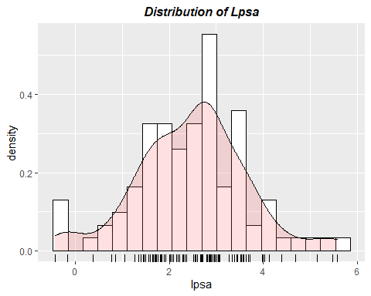

From the distribution plot above, we can see that the data are generally normal distributed, and there are some outliers less than zero

#Correlation between variables  
cor(prostate)

## lcavol lweight age lbph svi lcp  
## lcavol 1.00000000 0.194128387 0.2249999 0.02734971 0.53884500 0.67531058  
## lweight 0.19412839 1.000000000 0.3075247 0.43493174 0.10877818 0.10023889  
## age 0.22499988 0.307524741 1.0000000 0.35018592 0.11765804 0.12766778  
## lbph 0.02734971 0.434931744 0.3501859 1.00000000 -0.08584327 -0.00699944  
## svi 0.53884500 0.108778185 0.1176580 -0.08584327 1.00000000 0.67311122  
## lcp 0.67531058 0.100238891 0.1276678 -0.00699944 0.67311122 1.00000000  
## gleason 0.43241705 -0.001283003 0.2688916 0.07782044 0.32041222 0.51482991  
## pgg45 0.43365224 0.050846195 0.2761124 0.07846000 0.45764762 0.63152807  
## lpsa 0.73446028 0.354121818 0.1695929 0.17980950 0.56621818 0.54881316  
## gleason pgg45 lpsa  
## lcavol 0.432417052 0.4336522 0.7344603  
## lweight -0.001283003 0.0508462 0.3541218  
## age 0.268891599 0.2761124 0.1695929  
## lbph 0.077820444 0.0784600 0.1798095  
## svi 0.320412221 0.4576476 0.5662182  
## lcp 0.514829912 0.6315281 0.5488132  
## gleason 1.000000000 0.7519045 0.3689867  
## pgg45 0.751904512 1.0000000 0.4223157  
## lpsa 0.368986693 0.4223157 1.0000000

#Pair Plots  
library(ggplot2)  
library(GGally)  
ggpairs(prostate) +   
 ggtitle("Pair Plots of Prostate") +   
 theme(plot.title = element_text(hjust = 0.5, size=12, face="bold.italic"))

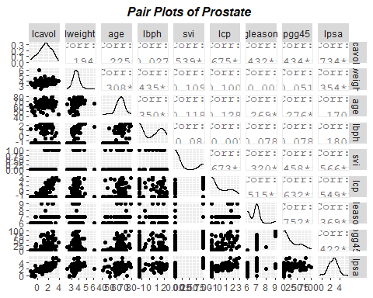

From the results above, we can see that *lcavol*, *lweight*, and *svi* has some correlations with *lpsa*. We can continue to define a linear model, and find deeper relationship.

# Variable Selection

#Build up full model  
full.lm = lm(formula = lpsa ~ lcavol + lweight + age + lbph + svi + lcp + gleason +   
 pgg45, data = prostate)  
print(summary(full.lm))

##   
## Call:  
## lm(formula = lpsa ~ lcavol + lweight + age + lbph + svi + lcp +   
## gleason + pgg45, data = prostate)  
##   
## Residuals:  
## Min 1Q Median 3Q Max   
## -1.7331 -0.3713 -0.0170 0.4141 1.6381   
##   
## Coefficients:  
## Estimate Std. Error t value Pr(>|t|)   
## (Intercept) 0.669337 1.296387 0.516 0.60693   
## lcavol 0.587022 0.087920 6.677 2.11e-09 ***  
## lweight 0.454467 0.170012 2.673 0.00896 **   
## age -0.019637 0.011173 -1.758 0.08229 .   
## lbph 0.107054 0.058449 1.832 0.07040 .   
## svi 0.766157 0.244309 3.136 0.00233 **   
## lcp -0.105474 0.091013 -1.159 0.24964   
## gleason 0.045142 0.157465 0.287 0.77503   
## pgg45 0.004525 0.004421 1.024 0.30886   
## ---  
## Signif. codes: 0 '***' 0.001 '**' 0.01 '*' 0.05 '.' 0.1 ' ' 1  
##   
## Residual standard error: 0.7084 on 88 degrees of freedom  
## Multiple R-squared: 0.6548, Adjusted R-squared: 0.6234   
## F-statistic: 20.86 on 8 and 88 DF, p-value: < 2.2e-16

#Apply backward selection model  
full.backward = step(full.lm, direction = "backward")

## Start: AIC=-58.32  
## lpsa ~ lcavol + lweight + age + lbph + svi + lcp + gleason +   
## pgg45  
##   
## Df Sum of Sq RSS AIC  
## - gleason 1 0.0412 44.204 -60.231  
## - pgg45 1 0.5258 44.689 -59.174  
## - lcp 1 0.6740 44.837 -58.853  
## <none> 44.163 -58.322  
## - age 1 1.5503 45.713 -56.975  
## - lbph 1 1.6835 45.847 -56.693  
## - lweight 1 3.5861 47.749 -52.749  
## - svi 1 4.9355 49.099 -50.046  
## - lcavol 1 22.3721 66.535 -20.567  
##   
## Step: AIC=-60.23  
## lpsa ~ lcavol + lweight + age + lbph + svi + lcp + pgg45  
##   
## Df Sum of Sq RSS AIC  
## - lcp 1 0.6623 44.867 -60.789  
## <none> 44.204 -60.231  
## - pgg45 1 1.1920 45.396 -59.650  
## - age 1 1.5166 45.721 -58.959  
## - lbph 1 1.7053 45.910 -58.560  
## - lweight 1 3.5462 47.750 -54.746  
## - svi 1 4.8984 49.103 -52.037  
## - lcavol 1 23.5039 67.708 -20.872  
##   
## Step: AIC=-60.79  
## lpsa ~ lcavol + lweight + age + lbph + svi + pgg45  
##   
## Df Sum of Sq RSS AIC  
## - pgg45 1 0.6590 45.526 -61.374  
## <none> 44.867 -60.789  
## - age 1 1.2649 46.131 -60.092  
## - lbph 1 1.6465 46.513 -59.293  
## - lweight 1 3.5647 48.431 -55.373  
## - svi 1 4.2503 49.117 -54.009  
## - lcavol 1 25.4189 70.285 -19.248  
##   
## Step: AIC=-61.37  
## lpsa ~ lcavol + lweight + age + lbph + svi  
##   
## Df Sum of Sq RSS AIC  
## <none> 45.526 -61.374  
## - age 1 0.9592 46.485 -61.352  
## - lbph 1 1.8568 47.382 -59.497  
## - lweight 1 3.2251 48.751 -56.735  
## - svi 1 5.9517 51.477 -51.456  
## - lcavol 1 28.7665 74.292 -15.871

print(summary(full.backward))

##   
## Call:  
## lm(formula = lpsa ~ lcavol + lweight + age + lbph + svi, data = prostate)  
##   
## Residuals:  
## Min 1Q Median 3Q Max   
## -1.83505 -0.39396 0.00414 0.46336 1.57888   
##   
## Coefficients:  
## Estimate Std. Error t value Pr(>|t|)   
## (Intercept) 0.95100 0.83175 1.143 0.255882   
## lcavol 0.56561 0.07459 7.583 2.77e-11 ***  
## lweight 0.42369 0.16687 2.539 0.012814 *   
## age -0.01489 0.01075 -1.385 0.169528   
## lbph 0.11184 0.05805 1.927 0.057160 .   
## svi 0.72095 0.20902 3.449 0.000854 ***  
## ---  
## Signif. codes: 0 '***' 0.001 '**' 0.01 '*' 0.05 '.' 0.1 ' ' 1  
##   
## Residual standard error: 0.7073 on 91 degrees of freedom  
## Multiple R-squared: 0.6441, Adjusted R-squared: 0.6245   
## F-statistic: 32.94 on 5 and 91 DF, p-value: < 2.2e-16

#Apply forward selection model  
full.forward <- step(lm(lpsa ~ 1, data=prostate), list(upper=full.lm), direction='forward')

## Start: AIC=28.84  
## lpsa ~ 1  
##   
## Df Sum of Sq RSS AIC  
## + lcavol 1 69.003 58.915 -44.366  
## + svi 1 41.011 86.907 -6.658  
## + lcp 1 38.528 89.389 -3.926  
## + pgg45 1 22.814 105.103 11.783  
## + gleason 1 17.416 110.501 16.641  
## + lweight 1 16.041 111.876 17.840  
## + lbph 1 4.136 123.782 27.650  
## + age 1 3.679 124.238 28.007  
## <none> 127.918 28.837  
##   
## Step: AIC=-44.37  
## lpsa ~ lcavol  
##   
## Df Sum of Sq RSS AIC  
## + lweight 1 5.9485 52.966 -52.690  
## + svi 1 5.2375 53.677 -51.397  
## + lbph 1 3.2658 55.649 -47.898  
## + pgg45 1 1.6980 57.217 -45.203  
## <none> 58.915 -44.366  
## + lcp 1 0.6562 58.259 -43.453  
## + gleason 1 0.4156 58.499 -43.053  
## + age 1 0.0025 58.912 -42.370  
##   
## Step: AIC=-52.69  
## lpsa ~ lcavol + lweight  
##   
## Df Sum of Sq RSS AIC  
## + svi 1 5.1814 47.785 -60.676  
## + pgg45 1 1.9489 51.017 -54.327  
## <none> 52.966 -52.690  
## + lcp 1 0.8371 52.129 -52.236  
## + gleason 1 0.7810 52.185 -52.131  
## + lbph 1 0.6751 52.291 -51.935  
## + age 1 0.4200 52.546 -51.463  
##   
## Step: AIC=-60.68  
## lpsa ~ lcavol + lweight + svi  
##   
## Df Sum of Sq RSS AIC  
## + lbph 1 1.30006 46.485 -61.352  
## <none> 47.785 -60.676  
## + pgg45 1 0.57347 47.211 -59.847  
## + age 1 0.40251 47.382 -59.497  
## + gleason 1 0.38901 47.396 -59.469  
## + lcp 1 0.06412 47.721 -58.806  
##   
## Step: AIC=-61.35  
## lpsa ~ lcavol + lweight + svi + lbph  
##   
## Df Sum of Sq RSS AIC  
## + age 1 0.95924 45.526 -61.374  
## <none> 46.485 -61.352  
## + pgg45 1 0.35332 46.131 -60.092  
## + gleason 1 0.21256 46.272 -59.796  
## + lcp 1 0.10230 46.383 -59.565  
##   
## Step: AIC=-61.37  
## lpsa ~ lcavol + lweight + svi + lbph + age  
##   
## Df Sum of Sq RSS AIC  
## <none> 45.526 -61.374  
## + pgg45 1 0.65896 44.867 -60.789  
## + gleason 1 0.45601 45.070 -60.351  
## + lcp 1 0.12927 45.396 -59.650

print(summary(full.forward))

##   
## Call:  
## lm(formula = lpsa ~ lcavol + lweight + svi + lbph + age, data = prostate)  
##   
## Residuals:  
## Min 1Q Median 3Q Max   
## -1.83505 -0.39396 0.00414 0.46336 1.57888   
##   
## Coefficients:  
## Estimate Std. Error t value Pr(>|t|)   
## (Intercept) 0.95100 0.83175 1.143 0.255882   
## lcavol 0.56561 0.07459 7.583 2.77e-11 ***  
## lweight 0.42369 0.16687 2.539 0.012814 *   
## svi 0.72095 0.20902 3.449 0.000854 ***  
## lbph 0.11184 0.05805 1.927 0.057160 .   
## age -0.01489 0.01075 -1.385 0.169528   
## ---  
## Signif. codes: 0 '***' 0.001 '**' 0.01 '*' 0.05 '.' 0.1 ' ' 1  
##   
## Residual standard error: 0.7073 on 91 degrees of freedom  
## Multiple R-squared: 0.6441, Adjusted R-squared: 0.6245   
## F-statistic: 32.94 on 5 and 91 DF, p-value: < 2.2e-16

I apply both backward and forward selection to the model, and have the same optimal model. According to the report, the optimal model is *lpsa ~ lcavol + lweight + age + lbph + svi*. However, the significant importance of some variables are mild. We may think of improving the model by transforming the variables.

# Exploration of Transformations

*Transform the response lpsa*

#Box-Cox Transformation of the response  
#Shift lpsa to all postive value  
prostate$'shift_lpsa' = prostate$lpsa+(-min(prostate$lpsa))+1  
  
library(MASS)  
full.bc = boxcox(shift_lpsa ~ lcavol + lweight + age + lbph + svi, data=prostate)

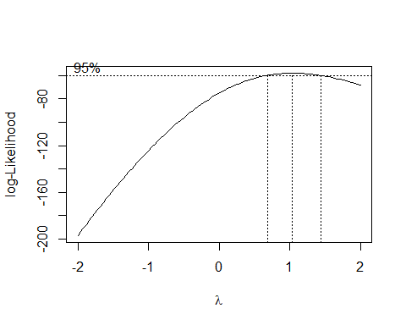

#Get the lamda of maximum log-Likelihood  
lamda.max = full.bc$x[full.bc$y==max(full.bc$y)]  
  
#Set up new Model  
bc.lm = lm(shift_lpsa^lamda.max ~ lcavol + lweight + age + lbph + svi, data=prostate)  
summary(bc.lm)

##   
## Call:  
## lm(formula = shift_lpsa^lamda.max ~ lcavol + lweight + age +   
## lbph + svi, data = prostate)  
##   
## Residuals:  
## Min 1Q Median 3Q Max   
## -1.97557 -0.42195 0.00096 0.49966 1.68867   
##   
## Coefficients:  
## Estimate Std. Error t value Pr(>|t|)   
## (Intercept) 2.45702 0.89141 2.756 0.007062 **   
## lcavol 0.60494 0.07994 7.567 2.98e-11 ***  
## lweight 0.45233 0.17884 2.529 0.013155 *   
## age -0.01608 0.01153 -1.395 0.166320   
## lbph 0.11908 0.06222 1.914 0.058780 .   
## svi 0.78126 0.22402 3.487 0.000753 ***  
## ---  
## Signif. codes: 0 '***' 0.001 '**' 0.01 '*' 0.05 '.' 0.1 ' ' 1  
##   
## Residual standard error: 0.758 on 91 degrees of freedom  
## Multiple R-squared: 0.6443, Adjusted R-squared: 0.6247   
## F-statistic: 32.96 on 5 and 91 DF, p-value: < 2.2e-16

From the result, we can see that the lamda of maximum log-Likelihood is very closed to 1. And the new model’s performance does not have too much change compared to the old one’s. Thus, I will still choose my final model as *lpsa ~ lcavol + lweight + age + lbph + svi*.

# Diagnostics of the Choosing Model

my.lm = lm(lpsa ~ lcavol + lweight + age + lbph + svi, data = prostate)  
summary(my.lm)

##   
## Call:  
## lm(formula = lpsa ~ lcavol + lweight + age + lbph + svi, data = prostate)  
##   
## Residuals:  
## Min 1Q Median 3Q Max   
## -1.83505 -0.39396 0.00414 0.46336 1.57888   
##   
## Coefficients:  
## Estimate Std. Error t value Pr(>|t|)   
## (Intercept) 0.95100 0.83175 1.143 0.255882   
## lcavol 0.56561 0.07459 7.583 2.77e-11 ***  
## lweight 0.42369 0.16687 2.539 0.012814 *   
## age -0.01489 0.01075 -1.385 0.169528   
## lbph 0.11184 0.05805 1.927 0.057160 .   
## svi 0.72095 0.20902 3.449 0.000854 ***  
## ---  
## Signif. codes: 0 '***' 0.001 '**' 0.01 '*' 0.05 '.' 0.1 ' ' 1  
##   
## Residual standard error: 0.7073 on 91 degrees of freedom  
## Multiple R-squared: 0.6441, Adjusted R-squared: 0.6245   
## F-statistic: 32.94 on 5 and 91 DF, p-value: < 2.2e-16

plot(my.lm)

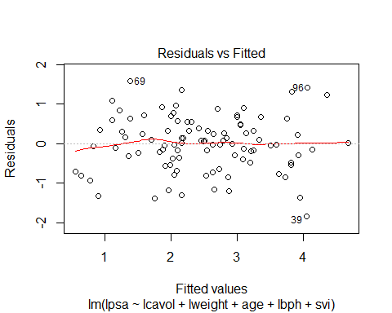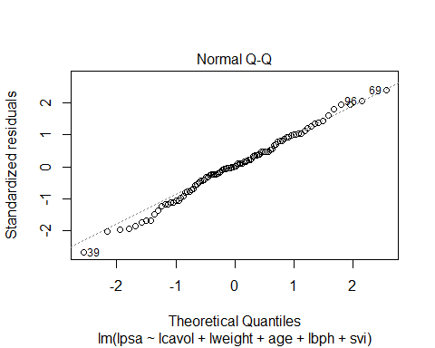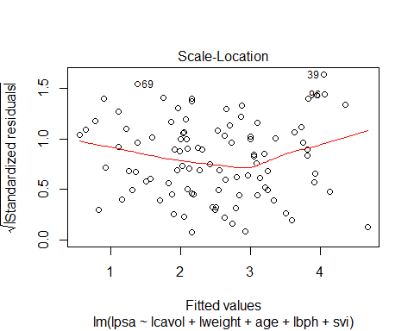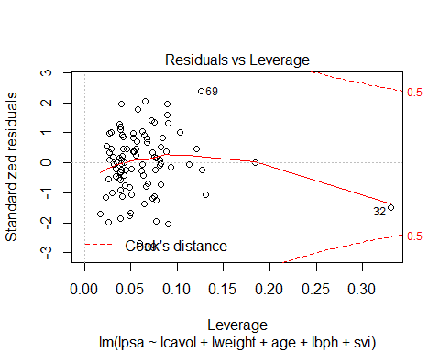

**Diagnosis Results:** From the *Residuals vs. fitted values*, we can see the scatterplot distributes randomly, with some exception outliers. From the *Normal Probability plot*, the points are generally follow the straight line. From the *Scale Lotion*, the plot shows a little downward pattern, but generally random. From the *Cook’s distance*, we can see there are some outliers affecting the model. Thus, according to the results above, I will pick the model, *lpsa ~ lcavol + lweight + age + lbph + svi*, as my optimal model for the future steps.

# Predictions of Future Observations

#New observations  
new.obs <- data.frame(  
 lcavol = runif(5, min = -2, max = 4),  
 lweight = runif(5, min = 2, max = 6),  
 age = floor(runif(5, min = 41, max = 79)),  
 lbph = runif(5, min = -2, max = 3),  
 svi = c(0,1,0,1,0),  
 lpsa = runif(5, min = -1, max = 6)  
)  
  
#Predict based on 99% prediction interval  
my.pre = predict(my.lm, se.fit=T, newdata=new.obs, interval='prediction', level = .99)  
my.pre$fit

## fit lwr upr  
## 1 0.4765702 -1.5003086 2.453449  
## 2 3.7363118 1.7659372 5.706686  
## 3 1.7036640 -0.2158876 3.623216  
## 4 2.1487595 -0.0243890 4.321908  
## 5 1.6531221 -0.3318426 3.638087

# Interpretation of the Model

summary(my.lm)

##   
## Call:  
## lm(formula = lpsa ~ lcavol + lweight + age + lbph + svi, data = prostate)  
##   
## Residuals:  
## Min 1Q Median 3Q Max   
## -1.83505 -0.39396 0.00414 0.46336 1.57888   
##   
## Coefficients:  
## Estimate Std. Error t value Pr(>|t|)   
## (Intercept) 0.95100 0.83175 1.143 0.255882   
## lcavol 0.56561 0.07459 7.583 2.77e-11 ***  
## lweight 0.42369 0.16687 2.539 0.012814 *   
## age -0.01489 0.01075 -1.385 0.169528   
## lbph 0.11184 0.05805 1.927 0.057160 .   
## svi 0.72095 0.20902 3.449 0.000854 ***  
## ---  
## Signif. codes: 0 '***' 0.001 '**' 0.01 '*' 0.05 '.' 0.1 ' ' 1  
##   
## Residual standard error: 0.7073 on 91 degrees of freedom  
## Multiple R-squared: 0.6441, Adjusted R-squared: 0.6245   
## F-statistic: 32.94 on 5 and 91 DF, p-value: < 2.2e-16

According to our model, *lpsa = 0.72svi + 0.11lbph - 0.01age + 0.42lweight + 0.57lcavol + 0.95*. The prostate specific antigen is postively related to the seminal vesicle invasion, cancer volume, prostate weight, and benign prostatic hyperplasia amount, but negatively related to age. The prostate specific antigen is greatly affect by cancer volume and seminal vesicle invasion.